1.

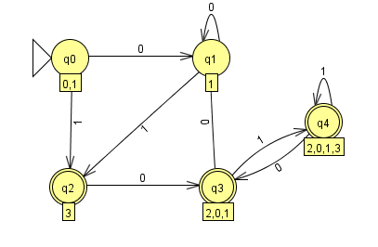

2.

Because an NFA M = ($Q,Σ{,q}_{0,}δ,F$) that accepts L = { *vwv* : *v, w $∈$* {*a,b*}\*, |*v*| = 2}

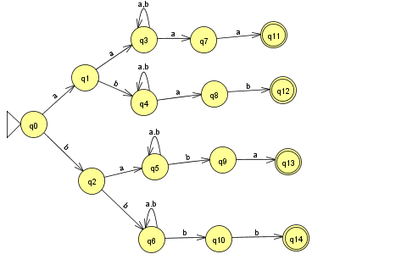

3

If L is regular , NFA M = {$Q_{A},Σ_{A},q_{A},F_{A},δ_{A}$} accept L(M).

Then NFA R = {$Q_{R},Σ_{R},q_{R},F_{R},δ_{R}$} where

$δ_{R}= δ_{A}^{ R}$, $q_{R}=F_{A},F_{R}=Q_{A}-F_{A}$.

Find the w∈ $Σ_{A}q,p∈Q_{A}$, there $δ_{R}(q,w)⇔ δ_{A}^{ }(p,w)$

So if L is regular language then $L^{R}$ is a regular

4.

a) L1 = { *w* : na(*w*) mod 3 = 1}.

Answer : $b^{*}a(b^{*}ab^{*}ab^{*}ab^{*})^{*}b^{*}$

b) L2 = { *w* : *w* ends in *aa* }.

${(a+b)}^{*}aa$

c) L3 = all strings containing no more than three *a*’s.

𝑏∗(𝑎 + 𝜆)𝑏∗(𝑎 + 𝜆)𝑏∗(𝑎 + 𝜆)𝑏∗

5.

Answer:

(“+” + “-” + $λ$) (1 + 2 + 3 + 4 + 5 + 6 +7 +8 + 9)(0 +1 + 2 + 3 + 4 + 5 + 6 +7 +8 + 9)\* (e (“+” + “-”)(0 +1 + 2 + 3 + 4 + 5 + 6 +7 +8 + 9) (0 +1 + 2 + 3 + 4 + 5 + 6 +7 +8 + 9) + $λ$)

6.

Answer:

a)

The regular grammar is 𝐺 = 𝑉, 𝑇, 𝑆, 𝑃 𝑤ℎ𝑒𝑟𝑒:

𝑉 = 𝑆, 𝐴, 𝐵

𝑇 = 𝑎, 𝑏

𝑃 = {𝑆 → 𝑏𝑆|𝑎𝐴, 𝐴 → 𝑏𝐵, 𝐵 → 𝑏𝐵|𝜆}

b)

The regular grammar is 𝐺 = 𝑉, 𝑇, 𝑆, 𝑃 𝑤ℎ𝑒𝑟𝑒:

𝑉 = {𝑆, 𝐴, 𝐵, 𝐶}

𝑇 = 𝑎, 𝑏

𝑃 = {𝑆 → 𝑏𝑆 𝑎𝐴, 𝐴 → 𝑏𝐴 𝑎𝐵 𝜆, 𝐵 → 𝑏𝐵 𝑎𝐶, 𝐶 → 𝑏𝐶|𝑎𝐴}